**PIZZA SALES SQL QUERIES & RESULTS**

# **A. KPI’s**

**1.Total Revenue;**

-- Gives Total Revenue from the Pizza Sales table

SELECT SUM(total_price) AS Total_Revenue from pizza_sales

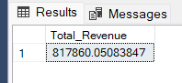

**2.Average Order Value;**

-- Gives Average Order Value from the Pizza Sales table

Select SUM(total_price) / COUNT(DISTINCT order_id) AS Average_Order_Value from pizza_sales

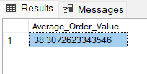

**3.Total Pizzas Sold;**

-- Gives Total Pizzas Sold from the Pizza Sales table

select SUM(quantity) AS Total_Pizzas_Sold from pizza_sales

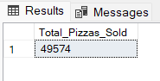

**4.Total Orders;**

-- Gives Total Orders from the Pizza Sales table

select COUNT(DISTINCT order_id) AS Total_Orders from pizza_sales

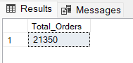

**5.Average Pizzas Per Order;**

-- Gives Average Pizzas Per Order from the Pizza Sales table

select CAST

(CAST(SUM(quantity) AS DECIMAL(10,2)) /

CAST(COUNT(DISTINCT order_id) AS DECIMAL(10,2))

AS DECIMAL(10,2))

AS Avg_Pizzas_per_order

from pizza_sales

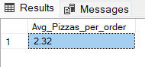

# **B. CHARTS REQUIREMENT**

**1.Daily Trend for Total Orders;**

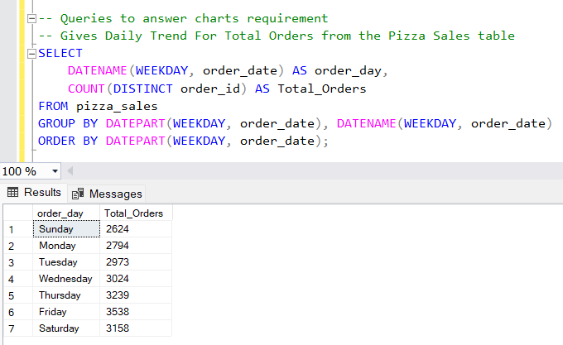

**2.Monthly Trend for Total Orders;**

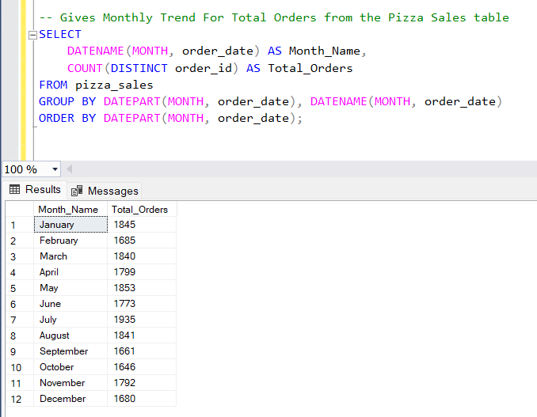

**3. % of Sales by Pizza Category;**

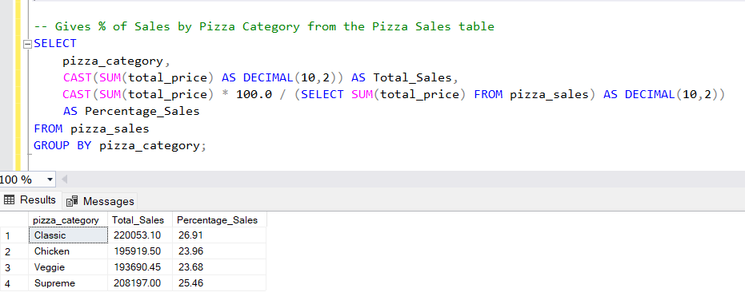

**4. % OF Sales by Pizza Size**

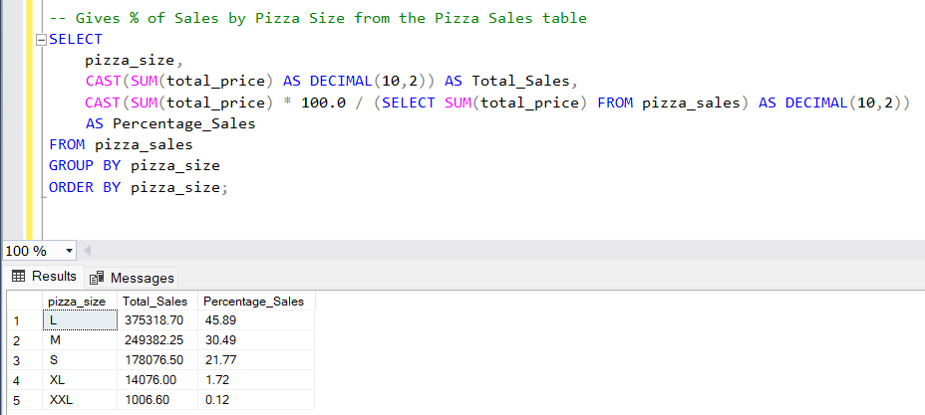

**5. Total Pizza Sold by Category;**

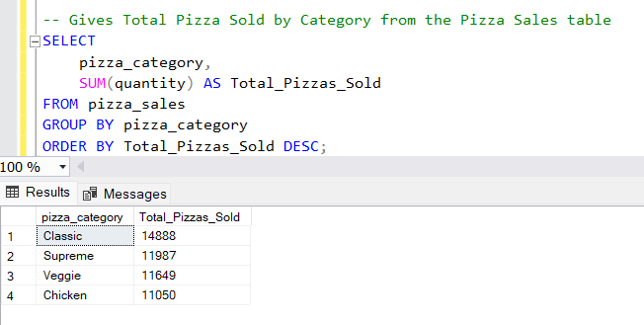

**6. Top 5 Pizzas by Revenue;**

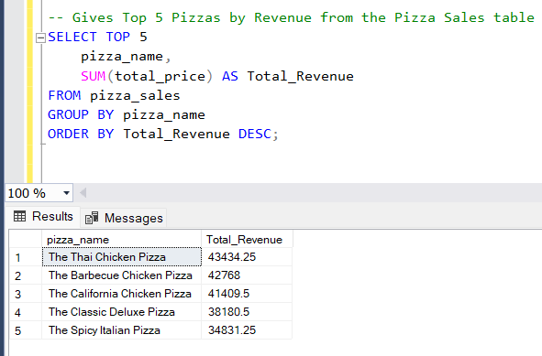

**7. Bottom 5 Pizzas by Revenue;**

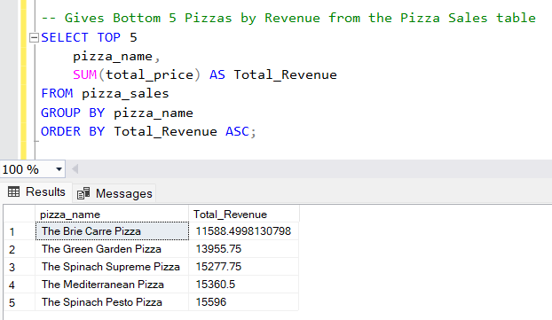

**8. Top 5 Pizzas by Total Quantity;**

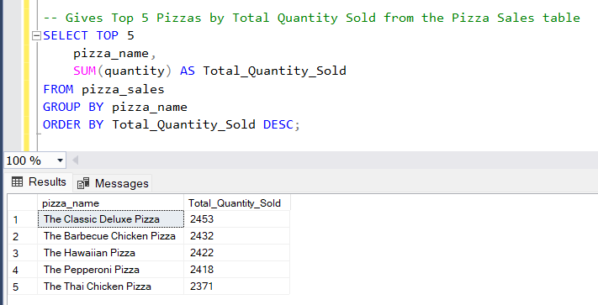

**9. Bottom 5 Pizzas by Total Quantity;**

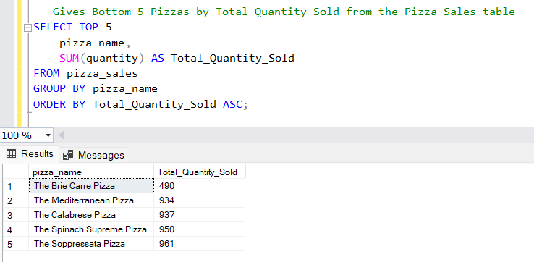

**10. Top 5 Pizzas by Total Orders;**

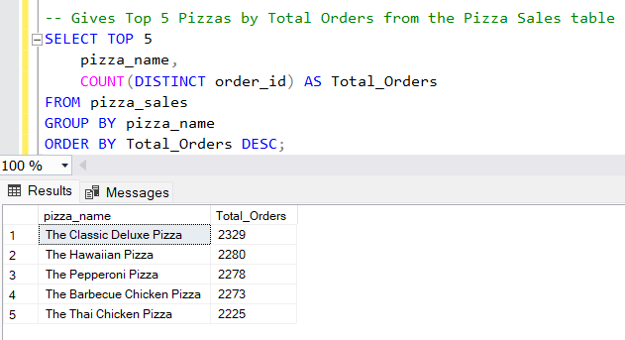

**11. Bottom 5 Pizzas by Total Orders;**

